select last_name,employee_id from employees where ( job_id = 'SA_REP') OR (job_id = 'AD_PRES') and (salary >=5000);

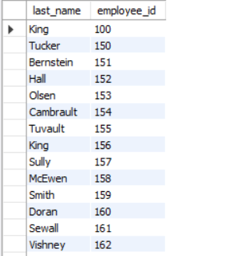

select last_name , salary*12 as anuualsal from employees order by salary DESC;

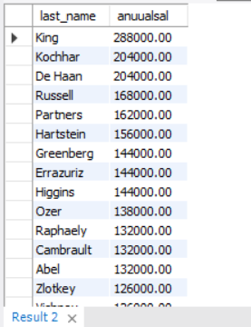

select employee_id , upper( last_name) from employees ;

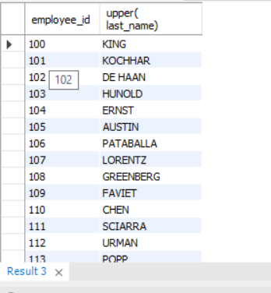

select employee_id , lower( last_name) from employees ;

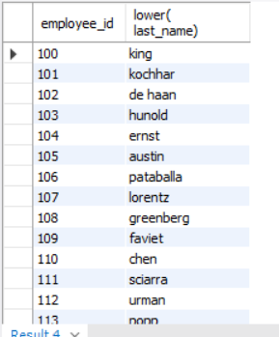

select employee_id,concat(first_name,last_name) as Name,job_id, length(last_name),instr(last_name,'a')from employees where substr(job_id,4)='REP';

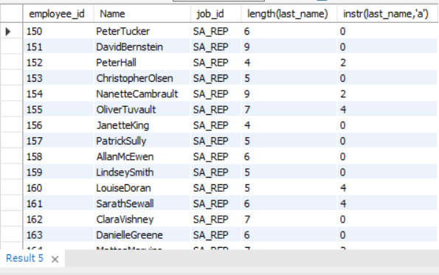

select avg(salary) as Avgsal , max(salary) as Maxsal , sum(salary) as Sumsal , min(salary) as Minsal from employees where department_id = 90 ;

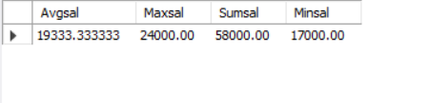

select avg(salary) as Avgsal , max(salary) as Maxsal , sum(salary) as Sumsal , min(salary) as Minsal from employees where department_id = 50 ;

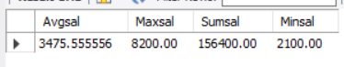

select min(hire_date), max(hire_date) from employees ;

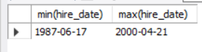

select * from employees;

select avg(commission_pct) from employees;

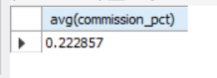

select sum(salary),department_id from employees group by department_id;

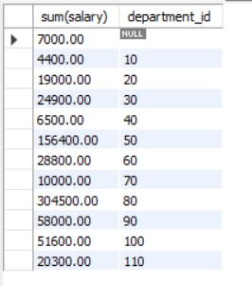

select avg(salary) as Avgsal , max(salary) as Maxsal , sum(salary) as Sumsal , min(salary) as Minsal from employees group by department_id;

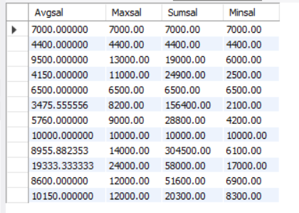

select sum(salary) from employees

group by department_id

order by department_id desc;

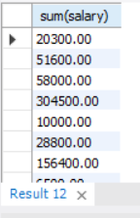

select avg(salary),department_id from employees

group by department_id

having (avg(salary)>8000);

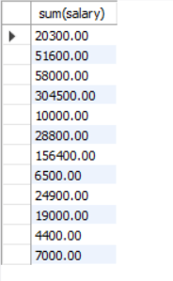

select max(salary),department_id from employees

group by department_id

having (max(salary)>10000);

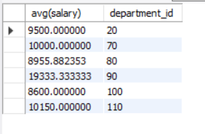

select job_id,sum(salary) from employees

where job_id NOT like '%REP%'

group by job_id

having sum(salary)>=12000

order by department_id

